1. **Create one VPC,with 1 one public subnet and 1 private subnet.**

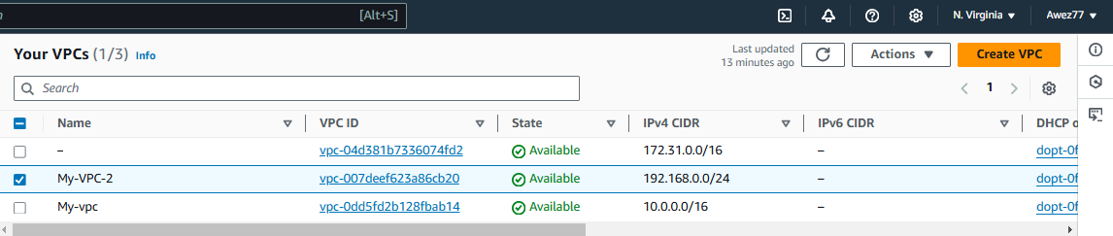

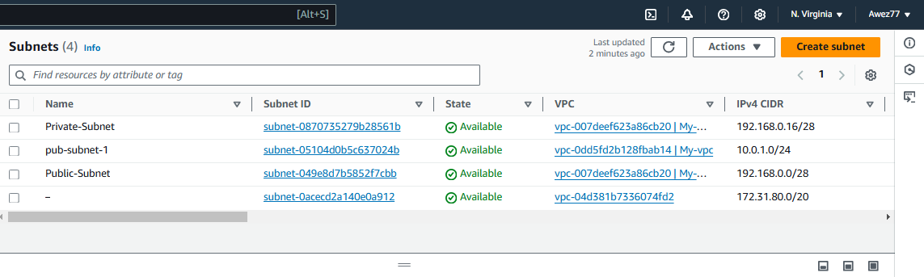

1. **Enable VPC peering for cross region.**

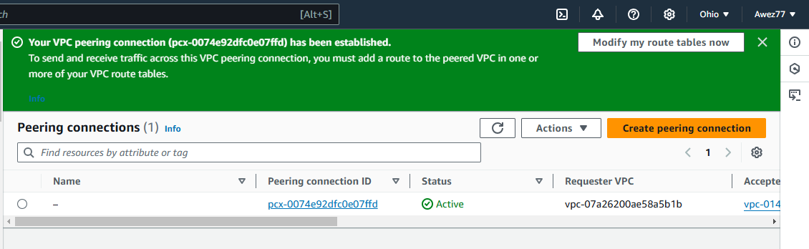

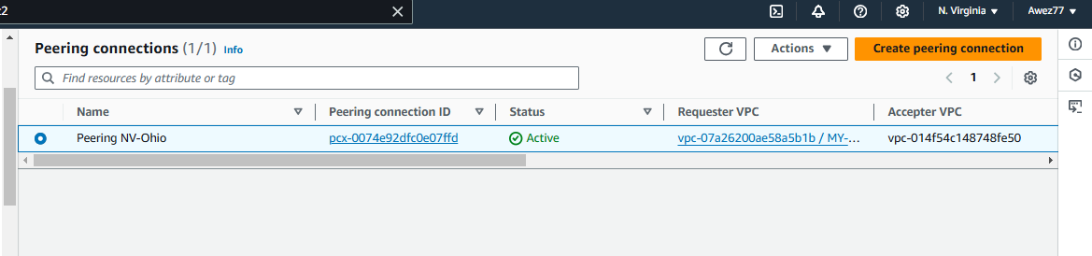

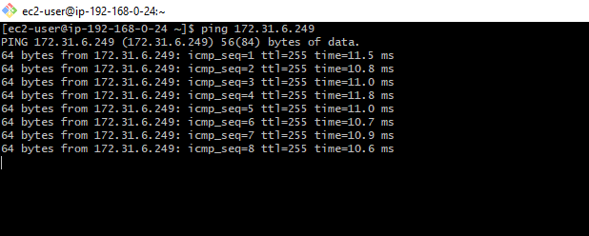

1. **Enable VPC peering for cross account. (You can collaborate with your friend and do this task).**

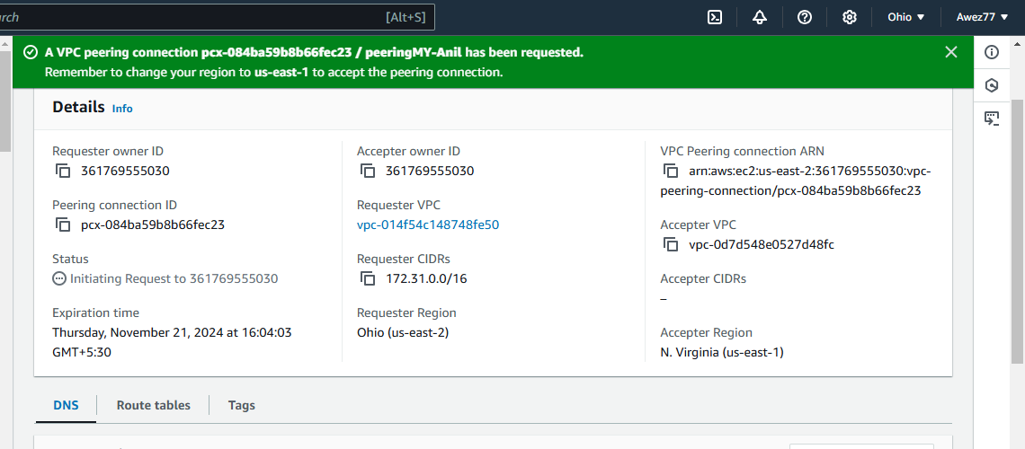

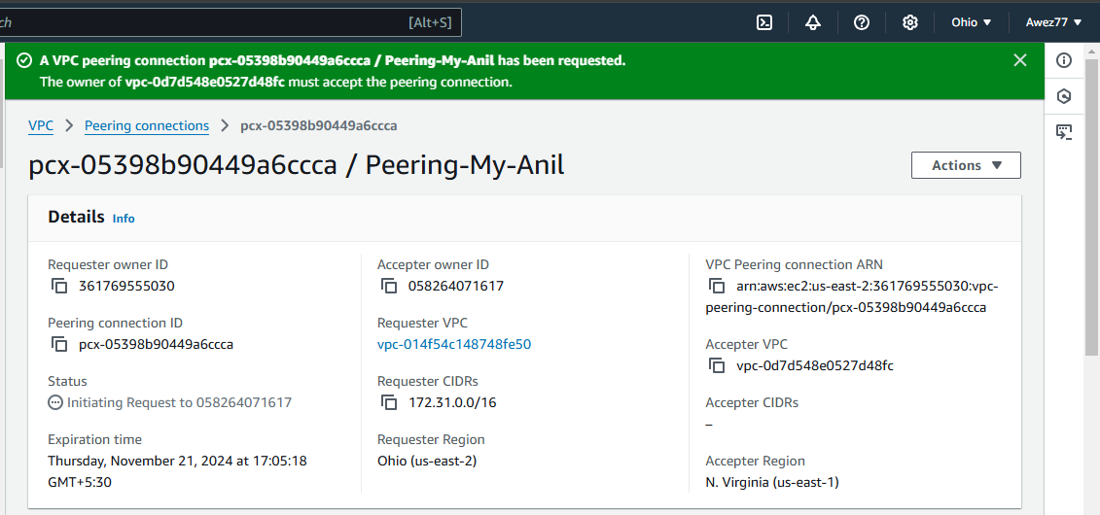

1. **Setup VPC Transist gateway.**

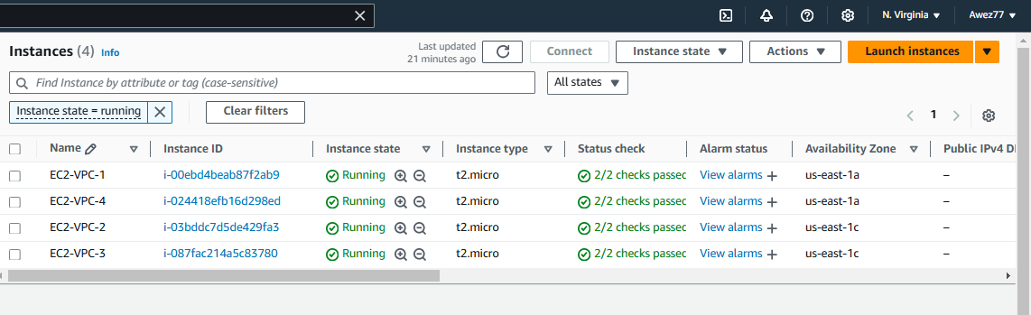

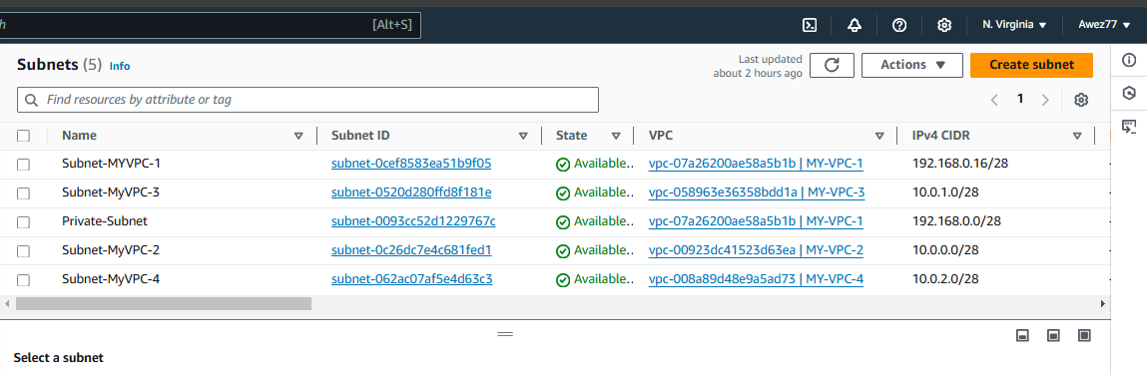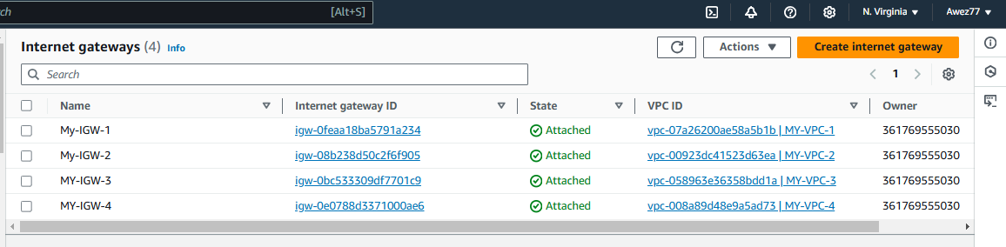

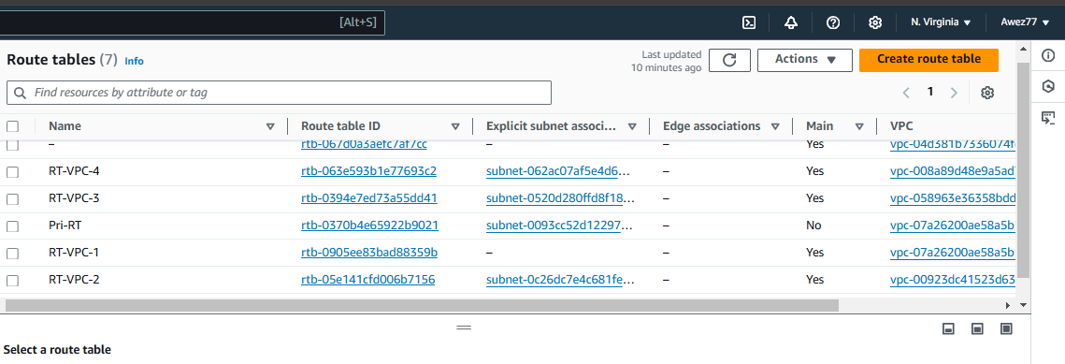

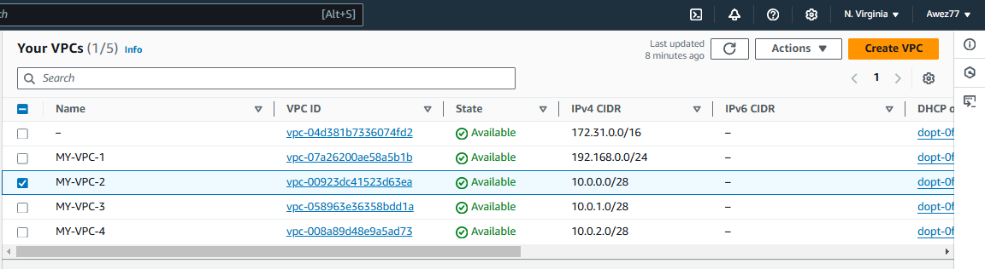

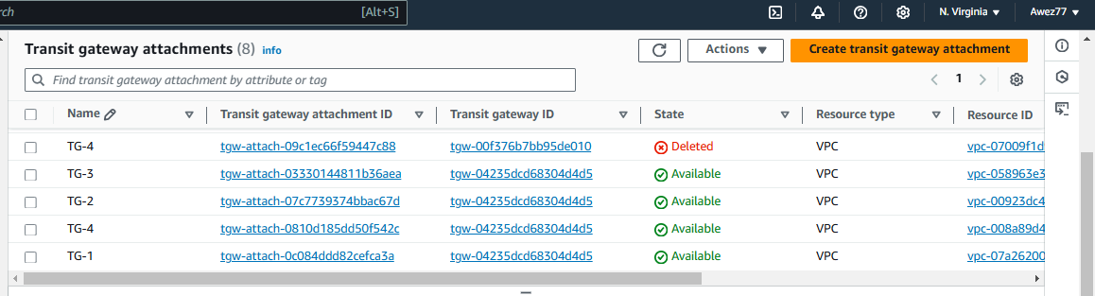

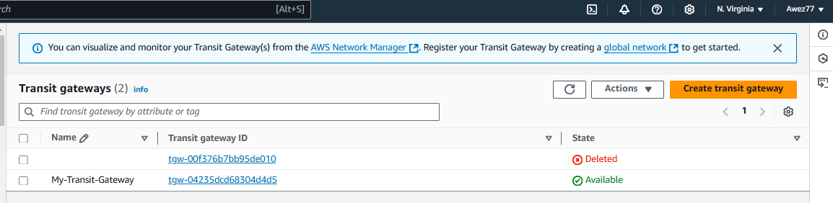

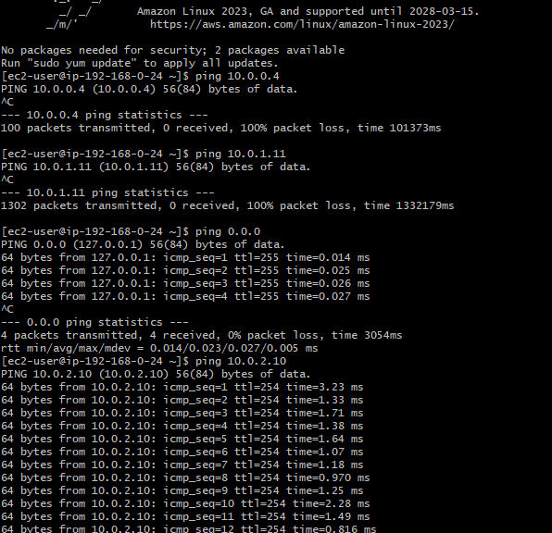

1. **Setup VPC End Point.**

